
IUBAT
International University of Business Agriculture & Technology

Course Title: Software Engineering Lab
Course Code: CSC 470
Topic: Use Case Diagram for Online Event Management System
Submitted By:
Name: Aononto Jahan Junnurain
ID: 21103030
Program: BCSE
Section: N

Submitted To:
Saha Kuljit Shantanu
Lecturer,
Department of CSE

Date of Submission: 12-01-2026
Table of Contents

1. Title of the Experiment 3
2. Objective 3
3. Introduction 3
4. Actors Identified 3
5. Description of the Use Case Diagram 4
5.1 Event Organizer and Administrator 4
5.2 Attendee 4
6. Use Case Relationships 4
7. System Functionality Representation 5
8. Result 5
9. Conclusion 5

1. Title of the Experiment
Use Case Diagram for Online Event Management System

2. Objective
The objective of this lab experiment is to analyze and represent the functional requirements of the Online Event Management System using a Use Case Diagram. The diagram illustrates the interaction between different system actors and the system functionalities.

3. Introduction
A Use Case Diagram is a Unified Modeling Language (UML) diagram that represents the interactions between external actors and a system. It helps in understanding system behavior from the user’s perspective and clearly defines system boundaries.
In this experiment, a Use Case Diagram is developed for an Online Event Management System to visualize how different users interact with the system for managing events and participating in them.

4. Actors Identified
The following actors are identified in the system:
- Event Organizer
- Administrator
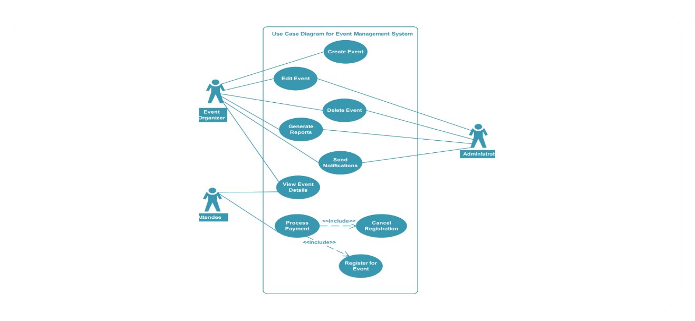
- Attendee

Each actor has specific roles and responsibilities within the system.

5. Description of the Use Case Diagram

5.1 Event Organizer and Administrator
The Event Organizer and Administrator share several key system privileges. They are responsible for managing and overseeing all event-related operations. Their main use cases include:
- Create Event
- Edit Event
- Delete Event
- Generate Reports
- Send Notifications
These use cases indicate their authority to control event data, monitor participation, and communicate with users.

5.2 Attendee
The Attendee represents users who participate in events. Attendees interact with the system through the following use cases:
- View Event Details
- Register for Event
- Process Payment
- Cancel Registration
The Register for Event and Process Payment use cases are connected through an <<include>> relationship, indicating that payment is a mandatory step for registering in paid events.

6. Use Case Relationships
The diagram uses include relationships to show dependency between actions:
- The Register for Event use case includes Process Payment, ensuring that registration is completed only after successful payment.
- The Cancel Registration use case allows attendees to withdraw from events when needed.
These relationships improve clarity and enforce logical system flow.

7. System Functionality Representation
The Use Case Diagram highlights two major system functionalities:
- Event Management: Managed by Event Organizers and Administrators through event creation, modification, deletion, reporting, and notifications.
- Participant Engagement: Managed by Attendees through viewing events, registration, payment processing, and cancellation.
This ensures smooth coordination between administrators, organizers, and participants.

8. Result
The Use Case Diagram successfully represents the interaction between actors and system functionalities. It clearly defines system boundaries, actor roles, and relationships between use cases, providing a comprehensive view of the system’s functional behavior.

9. Conclusion
This lab experiment demonstrates the importance of Use Case Diagrams in software design. The diagram provides a clear understanding of how different users interact with the Online Event Management System. By visualizing system behavior, the Use Case Diagram helps in requirement validation, system planning, and effective communication between stakeholders

